Garrett Dunn

IT-140

30 January 2021

Project One Storyboard: Alien Adventure

You wake up in a stinky, slimy room and realize that you have been abducted by an alien! The alien seems to have shady intentions, so you decide to overthrow the alien to take control of the ship. However, you must gather a few essential items before the battle! You will need a **Journal** from the **Slimy Room** to learn about the alien’s weak point (hint: it’s the stomach), your **Phone** from **The Lab** where it was undergoing tests, a **Plasma Gun** from the **Weapons Room** to shoot the alien, an **Alien Book** from **The Study** for further research of the alien and it’s language when you return to Earth, your **Wallet** from the **Storage Room** where you eerily find a pile of other wallets and belongings, and finally a **Souvenir** from the **Server Room** that is convincing enough to prove that you ACTUALLY got abducted by an alien. After you have located all of the required items, you can fight the alien in the **Control Room** to seize the ship and return to Earth!

Here is a map of the alien’s ship to help you navigate through this quest:

[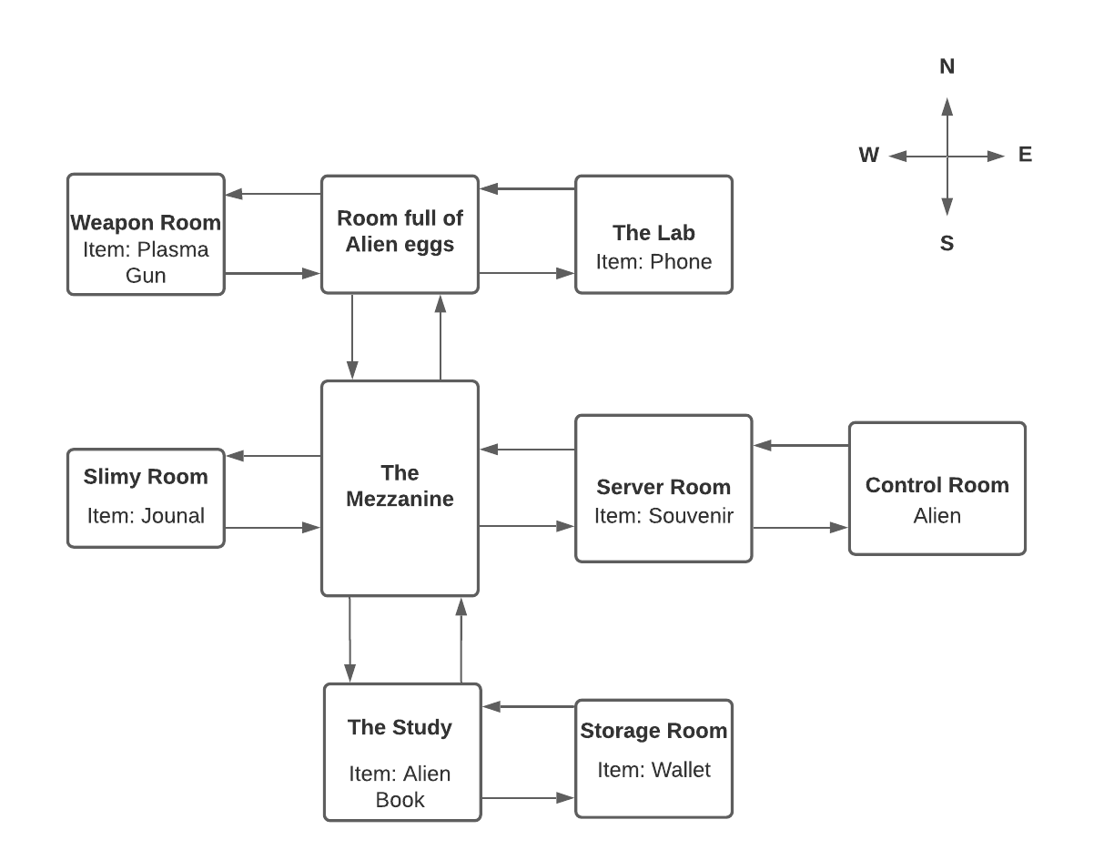](https://lucid.app/documents/edit/295c6daa-a0eb-4a9a-a1c7-a1bcebe7e48d/0?callback=close&name=docs&callback_type=back&v=1100&s=612)